Point Inside a Solid

Definition
# Source: AI Source: Provided by: [Data Path: Persons Table -> ID Column: 1, Name_En Column: Motasem Essam] -> From: [ChatGPT] on [7/25/2026]
A point inside a solid is a point whose position lies strictly within the three-dimensional interior of a solid, excluding its boundary.
In three-dimensional space, a point is represented by coordinates $\left(x,y,z\right)$. Whether the point is inside a solid depends on the geometric definition and boundaries of that solid.
For example, a point $P\left(x,y,z\right)$ is strictly inside a sphere of radius $r$, centered at the origin, if
$$x^{2}+y^{2}+z^{2}<r^{2}$$
The strict inequality means that the point is inside the sphere, not on its surface.

2. Simple Definition
# Source: AI Source: Provided by: [Data Path: Persons Table -> ID Column: 1, Name_En Column: Motasem Essam] -> From: [ChatGPT] on [7/25/2026]
A point inside a solid is a point located completely within a three-dimensional object, such as a point inside a cube, sphere, cylinder, or pyramid.
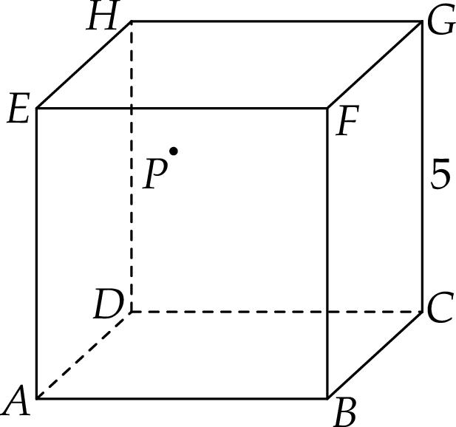
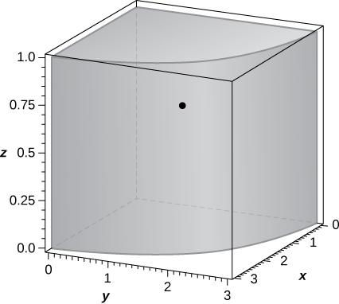
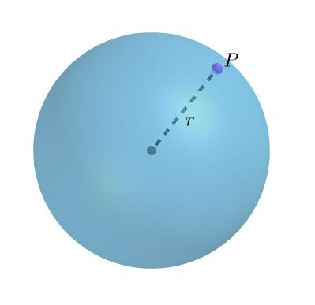

Key Characteristics
# Source: AI Source: Provided by: [Data Path: Persons Table -> ID Column: 1, Name_En Column: Motasem Essam] -> From: [ChatGPT] on [7/25/2026]
- Three-dimensional location: Represented by coordinates $\left(x,y,z\right)$.
- Zero-dimensional: A point has no length, width, or height.
- Strictly interior: It does not lie on the solid's boundary.
- Defined by the solid: The mathematical conditions for being inside depend on the solid's shape and dimensions.
- Positive distance from the boundary: For a bounded, regular solid, an interior point has a neighborhood lying entirely inside the solid.
- May occupy any interior position: It can be at the center, near a face, near an edge, or near a vertex while remaining strictly inside.

Types of Points Inside Solids

1. Point Inside a Polyhedron
# Source: AI Source: Provided by: [Data Path: Persons Table -> ID Column: 1, Name_En Column: Motasem Essam] -> From: [ChatGPT] on [7/25/2026]
A polyhedron is a solid bounded by flat polygonal faces, such as a cube, cuboid, prism, or pyramid.
For a cube occupying the region
$$0<x<4, 0<y<4, 0<z<4$$
the point $P\left(2,2,2\right)$ is strictly inside the cube because all three coordinates are between the corresponding boundary values.
Examples:
- A point inside a cube.
- A point inside a rectangular cuboid.
- A point inside a triangular prism.
- A point inside a pyramid.

2. Point Inside a Solid with Curved Surfaces
# Source: AI Source: Provided by: [Data Path: Persons Table -> ID Column: 1, Name_En Column: Motasem Essam] -> From: [ChatGPT] on [7/25/2026]
A solid with curved surfaces includes spheres, cylinders, cones, and ellipsoids.
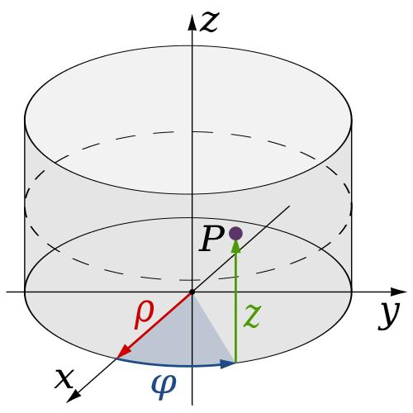
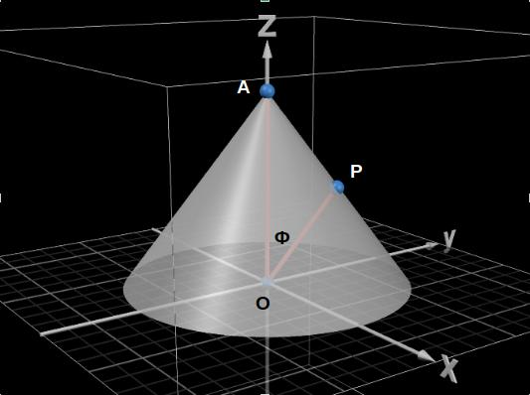
For a sphere centered at the origin with radius $r$, a point $P\left(x,y,z\right)$ lies inside if
$$x^{2}+y^{2}+z^{2}<r^{2}$$
For a right circular cylinder with radius $r$, centered on the $z$-axis and extending from $z=0$ to $z=h$, a point lies strictly inside if
$$x^{2}+y^{2}<r^{2}, 0<z<h$$
Both the curved side and the top and bottom boundaries must be excluded for a point to be strictly inside the cylinder.

3. Point at the Center of a Solid
# Source: AI Source: Provided by: [Data Path: Persons Table -> ID Column: 1, Name_En Column: Motasem Essam] -> From: [ChatGPT] on [7/25/2026]
The center is a particular point inside some solids. It is not necessarily the same as the center of every type of solid, and some solids do not have a unique natural center.
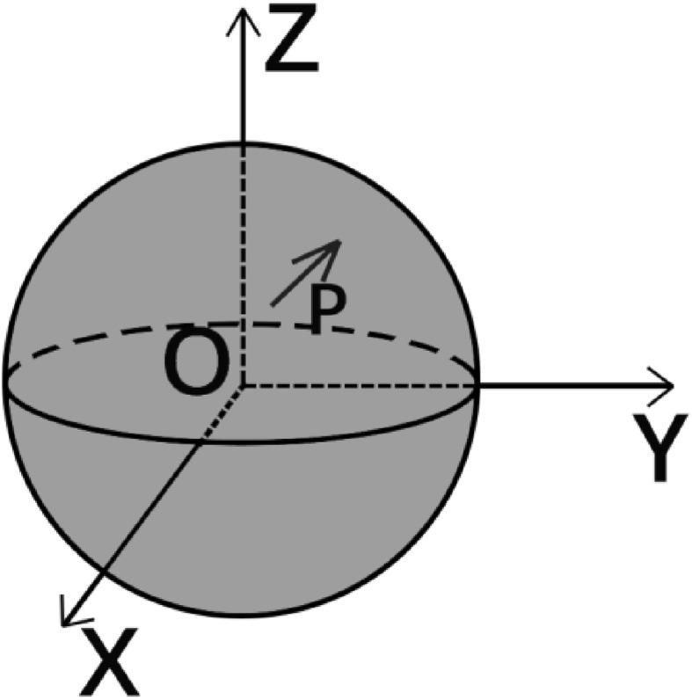
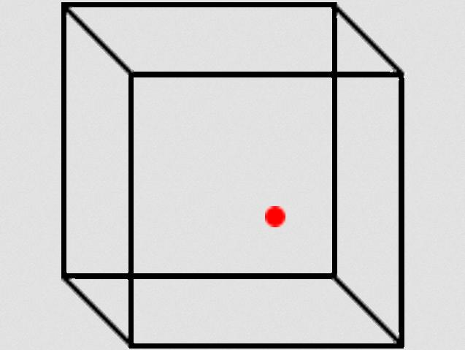
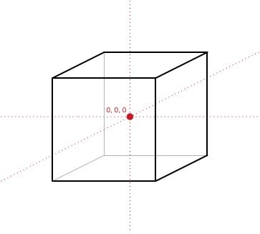
Examples include:
- Sphere: Its center is equally distant from every point on its surface.
- Cube: Its geometric center is the intersection of its space diagonals.
- Cuboid: Its geometric center is the midpoint of its space diagonals.
For a cuboid with opposite vertices $A\left(x_{1},y_{1},z_{1}\right)$ and $B\left(x_{2},y_{2},z_{2}\right)$, the center is
$$C=\left(\frac{x_{1}+x_{2}}{2},\frac{y_{1}+y_{2}}{2},\frac{z_{1}+z_{2}}{2}\right)$$
For a nondegenerate solid, this center lies strictly inside when it is the usual geometric center of the solid.

4. Point Inside a Composite Solid
# Source: AI Source: Provided by: [Data Path: Persons Table -> ID Column: 1, Name_En Column: Motasem Essam] -> From: [ChatGPT] on [7/25/2026]
A composite solid is formed by combining two or more simple solids.
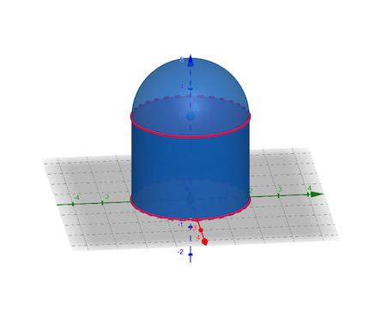
A point is inside a composite solid when it lies strictly within the volume of the combined object.
For example, if a hemisphere is joined to a cylinder, a point can be inside either component's volume. The joining surface is internal to the combined solid, so it is not necessarily part of the external boundary.

5. Point Near the Boundary but Still Inside
# Source: AI Source: Provided by: [Data Path: Persons Table -> ID Column: 1, Name_En Column: Motasem Essam] -> From: [ChatGPT] on [7/25/2026]
An interior point may lie very close to a face or curved surface without being on the boundary.
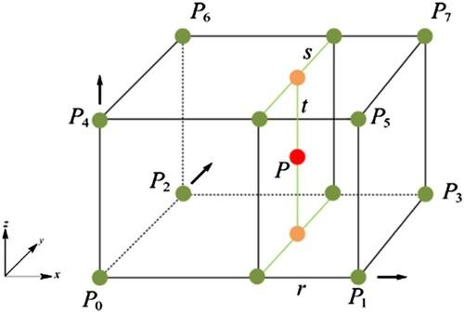
For a cube defined by $0≤x,y,z≤4$:
- $P\left(3.99,2,2\right)$ is inside the cube.
- $Q\left(4,2,2\right)$ is on the face $x=4$.
The distinction is important: a point can be arbitrarily close to the boundary and still be an interior point.

Mathematical Representation

1. General condition
# Source: AI Source: Provided by: [Data Path: Persons Table -> ID Column: 1, Name_En Column: Motasem Essam] -> From: [ChatGPT] on [7/25/2026]
Let $S$ be a solid and let $\operatorname{int}\left(S\right)$ denote its interior. A point $P$ is strictly inside the solid when
$$P∈\operatorname{int}\left(S\right)$$
For a regular closed solid, the points of the solid can be divided into interior points and boundary points:
$$S=\operatorname{int}\left(S\right)∪∂S$$
where $∂S$ denotes the boundary of the solid.

2. Examples of inside conditions
# Source: AI Source: Provided by: [Data Path: Persons Table -> ID Column: 1, Name_En Column: Motasem Essam] -> From: [ChatGPT] on [7/25/2026]
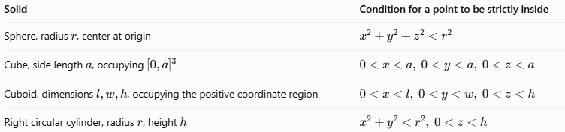
Solid | Condition for a point to be strictly inside
Sphere, radius $r$, center at origin | $$x^{2}+y^{2}+z^{2}<r^{2}$$
Cube, side length $a$, occupying ${\left[0,a\right]}^{3}$ | $$0<x<a, 0<y<a, 0<z<a$$
Cuboid, dimensions $l,w,h$, occupying the positive coordinate region | $$0<x<l, 0<y<w, 0<z<h$$
Right circular cylinder, radius $r$, height $h$ | $$x^{2}+y^{2}<r^{2}, 0<z<h$$
These equations assume the stated positions and orientations of the solids.

Worked Examples
# Source: AI Source: Provided by: [Data Path: Persons Table -> ID Column: 1, Name_En Column: Motasem Essam] -> From: [ChatGPT] on [7/25/2026]
Example 1: Point inside a sphere
A sphere is centered at the origin and has radius $5$. Determine whether $P\left(1,2,2\right)$ is inside it.
Calculate:
$$1^{2}+2^{2}+2^{2}=1+4+4=9$$
Since
$$9<5^{2}=25$$
Answer: $P\left(1,2,2\right)$ is strictly inside the sphere.
Example 2: Point inside a cube
A cube occupies $0≤x,y,z≤6$. Determine the position of $Q\left(2,3,4\right)$.
All coordinates satisfy
$$0<2<6, 0<3<6, 0<4<6$$
Answer: $Q$ is strictly inside the cube.
Example 3: Distinguishing an interior point from a boundary point
A sphere centered at the origin has radius $3$. Consider $R\left(3,0,0\right)$.
$$3^{2}+0^{2}+0^{2}=9=3^{2}$$
Answer: $R$ lies on the sphere's surface, so it is a boundary point, not an interior point.

Comparison with Related Concepts
# Source: AI Source: Provided by: [Data Path: Persons Table -> ID Column: 1, Name_En Column: Motasem Essam] -> From: [ChatGPT] on [7/25/2026]
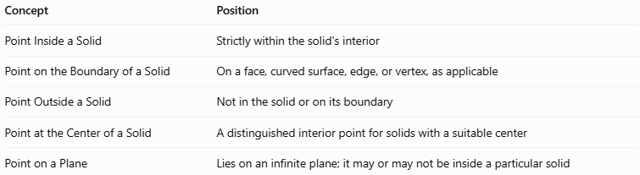
Concept | Position
Point Inside a Solid | Strictly within the solid's interior
Point on the Boundary of a Solid | On a face, curved surface, edge, or vertex, as applicable
Point Outside a Solid | Not in the solid or on its boundary
Point at the Center of a Solid | A distinguished interior point for solids with a suitable center
Point on a Plane | Lies on an infinite plane; it may or may not be inside a particular solid

Applications
# Source: AI Source: Provided by: [Data Path: Persons Table -> ID Column: 1, Name_En Column: Motasem Essam] -> From: [ChatGPT] on [7/25/2026]
- 3D modeling: Identifying points located within a modeled object.
- Computer graphics: Determining whether a point is inside a rendered volume.
- Engineering: Checking whether a component or measurement point lies within a physical part.
- Computational geometry: Testing whether a point belongs to a polyhedron or another bounded region.
- Physics: Describing positions within objects and material volumes.
- Architecture: Locating points within rooms, walls, and three-dimensional structures.

Key Points
# Source: AI Source: Provided by: [Data Path: Persons Table -> ID Column: 1, Name_En Column: Motasem Essam] -> From: [ChatGPT] on [7/25/2026]
- A point inside a solid lies strictly within its interior.
- An interior point is not on the solid's external boundary.
- The conditions for being inside depend on the solid's shape.
- A point at the center of a suitable solid is generally an interior point.
- Being close to a boundary does not make a point a boundary point.
- For a sphere, compare $x^{2}+y^{2}+z^{2}$ with $r^{2}$ to determine whether a point is inside, on, or outside.

Conclusion
# Source: AI Source: Provided by: [Data Path: Persons Table -> ID Column: 1, Name_En Column: Motasem Essam] -> From: [ChatGPT] on [7/25/2026]
A point inside a solid represents a location within the three-dimensional volume of a geometric object, excluding its boundary. This concept applies to polyhedra, curved solids, and composite solids. By using coordinates and the inequalities defining a solid, we can determine whether a point is inside the object, on its boundary, or outside it.

